Medical committee
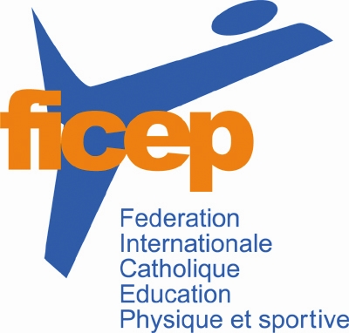

Declaration of consent

from the athletes of the ‘ficep’

A successful fight against doping is unthinkable without the active help of the athletes of FICEP, including in public. An important contribution is, among other things, the obligatory declaration of the athletes below.

I hereby declare that I am actively committed to a clean and manipulation-free sport.

Please fill in block letters:

First name, surname: __________________________________________________________

Date of birth: ___________________________________________________________

Street, house number: _____________________________________________________

Postcode, City: _________________________________________________________________

Association:______SPORTUNION Austria_______________________________________

Squad/Discipline: ____________________________________________________________

Gender: □ male - □ female - □ diverse (please tick the relevant field)

I have taken note of the FICEP Anti-Doping Code and submit to it (available on the associatin’s website: www.ficep.org ).

_______________________________________________________________________________
Place, date, signature (in the case of minors, the signatures of their legal guardians)

FICEP Summer Games 2026 - This declaration must be sent to the FICEP with the registration.

